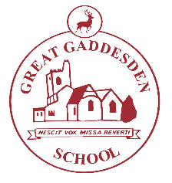
Great Gaddesden C of E

(Voluntary Aided) Primary School

Telephone 01442 255734 Headteacher: Mrs S Wickens

Great Gaddesden

Email admin@greatgaddesden.herts.sch.uk Hemel Hempstead

Herts

Website www.greatgaddesden.herts.sch.uk HP1 3BT

January 2019

Dear Parents/Carers,

This letter outlines the curriculum for Years 3 and 4 for the Spring Term. We are keen to share with you what we are learning in school in order for you to support your child/ren at home.

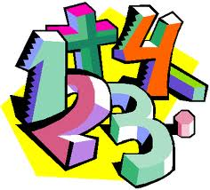
In Maths this term we will be studying the following units: Number and Place Value, Addition and Subtraction, Multiplication and Division, Fractions, Statistic, Measurement, Geometry: Properties of Shape, Geometry: Position and Direction as well as developing our mental maths skills and our problem-solving skills. In addition we will be focusing upon the rapid recall of multiplication facts and the corresponding division fact.

In English this term, we will be studying the following units: Reports, Structured poetry and Narrative Writing. We will be inspired by the work of Michael Morpurgo’s Kensuke’s Kingdom and the Atlas of Adventures by Lucy Letherland.

In R.E. this half-term we will be studying some of the events in Jesus’ life including creating his timeline and exploring some of the messages from the stories.
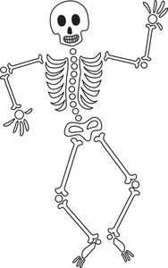

In our Science lessons, our topic is ‘ Animals, including humans. We will be looking at nutrition and the food pyramid, the human skeleton and the muscular system

In Geography this term our topic is Modern Europe. We will be learning about the human and physical features of the different countries that make up the European continent.

Our ICT lessons will be focused on learning how to email and how to write an email.

In Art this term we will be developing our drawing skills. We will be learning about the work of the British sculptors, Barbara Hepworth and Henry Moore.

During our DT lessons we will be investigating a range of European breads. The children will have chance to taste a range of ingredients and make their own bread.

In Music this term, children will be continuing learning how to play the recorder. These lessons will be delivered by the Hertfordshire Wider Opportunities Music Scheme.

During our P.E. and Games lessons we will be learning the skills needed for playing basketball, gymnastics and country dancing.

In PSHE this term, we will be learning about zones of regulation which focuses on children learning to understand how they are feeling and what they can do about those feelings. After half term we will looking at citizenship and how the children are part of a community.

Finally, homework will be set on a Wednesday ready to be handed back into school on Monday. Homework will consist of one written piece of homework linking to work children have done in class, a times table and spelling list to practise over the week as well as a My Maths focus. If you have any questions or concerns about your child’s homework please feel free to leave a comment in their homework book or come and see us. We really appreciate your input and support.

As always, please do not hesitate to contact us if you have any questions or queries regarding the content of this letter.

Yours sincerely,

Mrs Jessop and Mrs Lilley

