EYFS Small Schools week timetable
 | Monday | Tuesday | Wednesday | Thursday | Friday
a.m. | Sports Festival at Hemel Sportspace | Baking | Karate | Circus Skills | Fun art day
p.m. | Creating obstacle courses and games  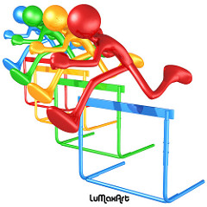 | School picnic  (Nursery welcome to stay)  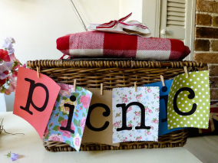 | Forest School expedition with Year 1 and 2  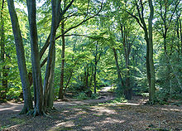 | Natural art workshop

