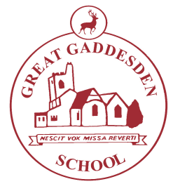
Great Gaddesden C of E

(Voluntary Aided) Primary School

Telephone 01442 255734 Headteacher: Mrs S. Wickens

Fax 01442 255107 Great Gaddesden C of E School

Hemel Hempstead

Email: admin@greatgaddesden.herts.sch.uk Herts

Website www.greatgaddesden.herts.sch.uk HP1 3BT

Spring 1, 2018
Dear Parents,

This letter outlines the curriculum for Years 1&2 over this academic term. We are keen to share with you what we are doing in school in order for you to support your children at home.

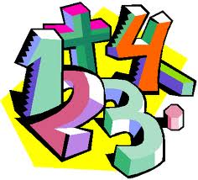
In Maths this term, we shall be learning about:

- Number and place value
- Addition and subtraction
- Multiplication and division
- Statistics

We will also practice rapid recall of number facts. If you are supporting your child with Maths at home, please work on counting forwards and backwards to and from 100, number bonds within 10 and 20, adding and taking away 10 from any number and the 2, 5 and 10 times tables.

In English this term, we shall be learning about the following genres:
- Instructions
- Stories with predictable phrasing
- Poetry

This term there will be a strong focus on letter formation, handwriting and spelling. Please support us in this by supervising the spelling homework and ensuring that your child forms their letters correctly and neatly.
In D.T. we will be looking at Structures. We will look at the structure of a house and apply what we have learnt to create our own castles.

In Science we are studying seasonal change. We will be observing how the seasons change and what this means for the weather, plants and wildlife.

In our R.E. lessons we will be learning about Special Places, Sacred Spaces including places of worship in different religions. We will discuss the importance of these spaces and hopefully be able to visit a place of worship.

In Music we are going to be listening to the different beats and pulses we can hear in pieces of music.

In P.E. we will be develop our large ball skills and we will continue to develop our movement skills in Dance.

In our Computing lessons, we will be collectors as we search the web for images and learn how to save these.
In our History lessons we are going to be studying castles. We will learn about the parts of a castle, notable castles as well as the history of monarchs.

In PSHE we will be concentrating on being responsible. We will be discussing making the right choices and how to be kind and helpful.

We would like you to read the school reading books with your child daily for 5 or 10 minutes every evening as well as sharing other books you may have at home. Please record in the Reading Diary when you have heard your child read.

Finally, homework in Year 1&2 is designed to be completed in no more than 10 or 15 minutes each night and will be of great benefit as your child progresses in their learning.

Your child will also have 5 or 10 spellings to practice using the Look Cover Write Check sheet. Please complete one column a day in pencil and encourage your child to form their letters correctly. Your child will be tested on these every week.

Your child may also have high frequency words (key words) to practice. These are designed to help your child build fluency with their reading. Try and practice these daily as your child needs to recognise these words in a random order.

Please do not hesitate to contact me if you have any questions or queries regarding the content of this letter.

Yours sincerely,

Miss Carty

