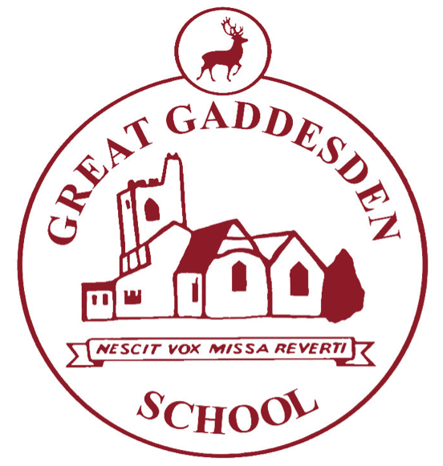
Homework at Great Gaddesden C of E School (VA)

Term: | Autumn 1, 2018 | Year Group/s: | 3-4
At Great Gaddesden C of E School, we provide homework for three reasons:

- To reinforce learning that takes place in school.
- To give children further opportunities to develop their love of learning.
- To prepare children for the next stage in their learning, at secondary school, when the volume of homework significantly increases.

- Homework books should be handed in every Monday (unless specified otherwise) and will be returned on Wednesdays.
- Please write in your child’s reading record whenever you hear them read – this is true even if they are a free reader.
- Times tables test: A record of your child’s times-table achievements are completed in the back of their homework books.
- If homework is not completed, children will be expected to stay in, either at break or lunch-time, to complete it.
- When choosing a reading book, consider selecting from one of the following authors: Michael Morpurgo, Roald Dahl, Philip Pullman, Terry Pratchett, Anthony Horowitz, Alex Shearer, Caroline Lawrence, JK Rowling, Lauren Child, Lemony Snickett, CS Lewis, Laura Ingalls Wilder.

Homework Set | Homework
Wednesday 12th September | Focus: Maths (DL)  WALT: Learn the multiplication tables.  Task: Complete the times table grid provided. You do not need to do this in a set time. Take your time, work out the sums and complete accurately. You may use a calculator to help you with the more ‘trickier’ sums.  Extension and Yr 4: Choose a times table you are unfamiliar with and learn it by heart.  WILF: Neat presentation and sums calculated accurately.  Spelling: Please see your child’s Look, Cover, Write, Check sheet to see their spelling score for this week. Please ensure they spend time each day completing a column of this week’s spelling words. This is an opportunity to practice letter formation and handwriting as well as spelling.  My Maths: Our Maths topics this half-term include number and place value, addition and subtraction, shape and position and movement. Please encourage your child to access these topics on My Maths.
Wednesday19th September | Focus: English (DL)  WALT: Use technical vocabulary when discussing my reading/writing.  WILF: Write a definition of the following and include a sentence to show your understanding.  - Capital letter at the start of a sentence  - A capital letter used for a proper noun.  - A full stop at the end of a sentence.  - A question mark.  - An exclamation mark.  Extension and Year 4:  - A command sentence.  - A statement sentence.  Spelling: Please see your child’s Look, Cover, Write, Check sheet to see their spelling score for this week. Please ensure they spend time each day completing a column of this week’s spelling words. This is an opportunity to practice letter formation and handwriting as well as spelling.  My Maths: Our Maths topics this half-term include number and place value, addition and subtraction, shape and position and movement. Please encourage your child to access these topics on My Maths.
Wednesday 26th September | Focus: Speaking & Listening (DL)  WALT: Learn by heart and recite a poem  Task: Today you will take home a poem (yet to be decided)to learn by heart. You will be presenting this poem as a class to the rest of the school  WILF:  - Confident recital of the poem.  - Eye contact with your audience  Spelling: Please see your child’s Look, Cover, Write, Check sheet to see their spelling score for this week. Please ensure they spend time each day completing a column of this week’s spelling words. This is an opportunity to practice letter formation and handwriting as well as spelling.  My Maths: Our Maths topics this half-term include number and place value, addition and subtraction, shape and position and movement. Please encourage your child to access these topics on My Maths.
Wednesday 3rd October | Focus: Science (CJ)  WALT: Research scientific facts  Task: Find out about a dinosaur fossil  WILF: Research about a dinosaur fossil using books or the internet  Make notes and then complete the sheet with your best handwriting.  Spelling: Please see your child’s Look, Cover, Write, Check sheet to see their spelling score for this week. Please ensure they spend time each day completing a column of this week’s spelling words. This is an opportunity to practice letter formation and handwriting as well as spelling.  My Maths: Our Maths topics this half-term include number and place value, addition and subtraction, shape and position and movement. Please encourage your child to access these topics on My Maths.
Wednesday10th  October | Focus: Art (DL)  WALT: Observe and accurately draw a still life.  Task: Arrange a small collection of simple objects e.g a box, tin and a jar. Look at the objects carefully and draw what you see.  WILF: A neat pencil drawing  - Excellent presentation  - Accurate observation  Spelling: Please see your child’s Look, Cover, Write, Check sheet to see their spelling score for this week. Please ensure they spend time each day completing a column of this week’s spelling words. This is an opportunity to practice letter formation and handwriting as well as spelling.  My Maths: Our Maths topics this half-term include number and place value, addition and subtraction, shape and position and movement. Please encourage your child to access these topics on My Maths.
Wednesday 17th  October | Focus: RE  WALT: Describe key facts about two religions  Task: Write five facts about the Christian and Islamic faith  WILF:  - Write a list of key facts about the Christian and Islamic faith. Eg What do they believe in? What is their holy book called? Where do they worship? How many worship this faith? Name and describe a key celebration.  - Write full sentences using a capital letter and full stop.  - Ext: Add a drawing to illustrate the fact.  The BBC have useful information, see this link. http://www.bbc.co.uk/schools/religion/islam/  Spelling: Please see your child’s Look, Cover, Write, Check sheet to see their spelling score for this week. Please ensure they spend time each day completing a column of this week’s spelling words. This is an opportunity to practice letter formation and handwriting as well as spelling.  My Maths: Our Maths topics this half-term include number and place value, addition and subtraction, shape and position and movement. Please encourage your child to access these topics on My Maths.
Wednesday 24th October | Focus: History (DL)  WALT: Research an aspect of Stone Age life.  Task: Write a short paragraph describing an aspect of Stone Age life. Choose from making and using tools, preparing and cooking food or Stone Age art.  WILF:  - Full stops and capital letters  - Neat joined up handwriting  - Illustrations  Extension and Yr 4: Choose two or more aspects of Stone Age life to research.  Spelling: Please see your child’s Look, Cover, Write, Check sheet to see their spelling score for this week. Please ensure they spend time each day completing a column of this week’s spelling words. This is an opportunity to practice letter formation and handwriting as well as spelling.  My Maths: Our Maths topics this half-term include number and place value, addition and subtraction, shape and position and movement. Please encourage your child to access these topics on My Maths.

