Great Gaddesden C of E (VA) Primary School
Headteacher : Mrs S.M.Wickens

Great Gaddesden C of E Primary School

Church Meadow,

Great Gaddesden
Email: admin@greatgaddesden.herts.sch.uk HP1 3BT Website: www.greatgaddesden.herts.sch.uk Herts
Tel: 01442 255734

July 2020

Dear Year 5 & 6,

Welcome to the weekly class letter, I hope you are all well.

Summer term 2nd half WEEK 7: week beginning 13.7.20

This week I would like you to work through the following:

English & Maths | Each day follow the BBC Bitesize learning task. There is a short video clip and activities each day.  Read each day for at least 20 minutes (it could be a book from the reading challenge)  Year 5 English & maths timetable  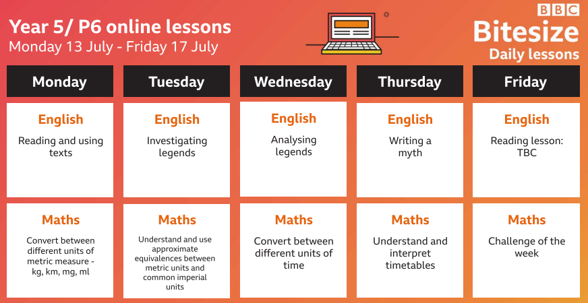
RE | LO: Learn about the life of Guru Nanak  Read through the Power Point and create a time line of the life of Guru Nanak
PE | Complete a daily Joe Wicks workout  https://www.youtube.com/watch?v=lEWcBIvqjDk
French | Sign up to Duolingo.com, this is free of charge and challenges you to fun, daily activities.
History | Each week, Radio 4 will be releasing a 15 minute history lesson. You can listen live at 9:30 each Monday or catch up on BBC Sounds.  https://www.bbc.co.uk/programmes/m000hmmf/episodes/guide

Please do not hesitate to contact us if you have any queries/questions about the content of this letter.

Yours sincerely,

Mrs Lilley

