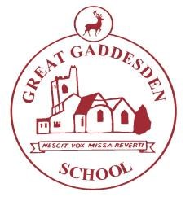
Great Gaddesden Cof E (VA) Primary School
Headteacher: Mrs S. Wickens

Great Gaddesden C of E Primary School
Email: admin@greatgaddesden.herts.sch.uk | Hemel Hempstead
Website: www.greatgaddesden.herts.sch.uk  Telephone: 01442 255734 | Herts  HP1 3BT
Thursday 8th March 2018

Dear Parents/Carers,

Parents Evening will be held on Tuesday 20th March and Wednesday 21st March this term. Appointments with class teachers are now available to book via our online booking system. Instructions on how to book an appointment are detailed below. Please note that appointments are only for 10 minutes per child.

If you are seeing two or more teachers, please leave a 10 minute gap between appointments.

Instructions for Booking Parents Evening:

Step One: Click on the link http://greatgaddesdenschool.setmore.com or copy and paste into a browser
Step Two: Click “Okay” once you have read the booking policy, and then click “Parents Evening”
Step Three: Select the relevant teacher
Step Four: Select the date you require
Tuesday 20th March 2018 3:30pm – 5:30pm and Wednesday 21st March 2018 from 5:30pm
(Please note you need to click on the date in the calendar)
Step Five: Select your chosen time from options on the right hand side. (Please note, if a time isn’t available, this means it has already been taken).
Step Six: Select ‘Skip login process’ and enter your details - Your name, email address & your child’s name. Press Continue.

Step Seven: Click “Book my Appointment” and you will receive a confirmation of your booking via email. Please feel free to get in touch if you experience any difficulty.
Kind regards,

Mrs A. Birch-Palmer

