Great Gaddesden C of E (VA) Primary School
Headteacher : Mrs S.M.Wickens

Great Gaddesden C of E Primary School

Church Meadow,

Great Gaddesden
Email: admin@greatgaddesden.herts.sch.uk HP1 3BT Website: www.greatgaddesden.herts.sch.uk Herts
Tel: 01442 255734

May 2020

Dear Year 5 & 6,

Welcome to the weekly class letter, I hope you are all well.

WEEK 5: week beginning 18.5.20

This week I would like you to work through the following:

English & Maths | Each day follow the BBC Bitesize learning task. There is a short video clip and activities each day.  We will be working one week behind so all 5 lessons will be available immediately (e.g. this week we will be looking at the lessons beginning 11th May).  Read each day for at least 20 minutes (it could be a book from the reading challenge)  Year 5 English & maths timetable  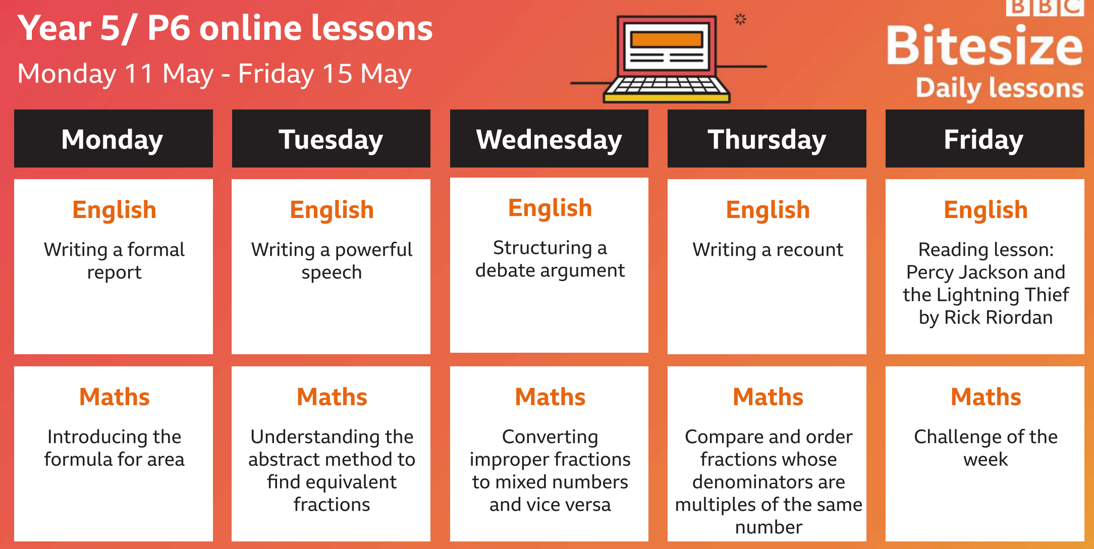  Yr 6 English & Maths timetable  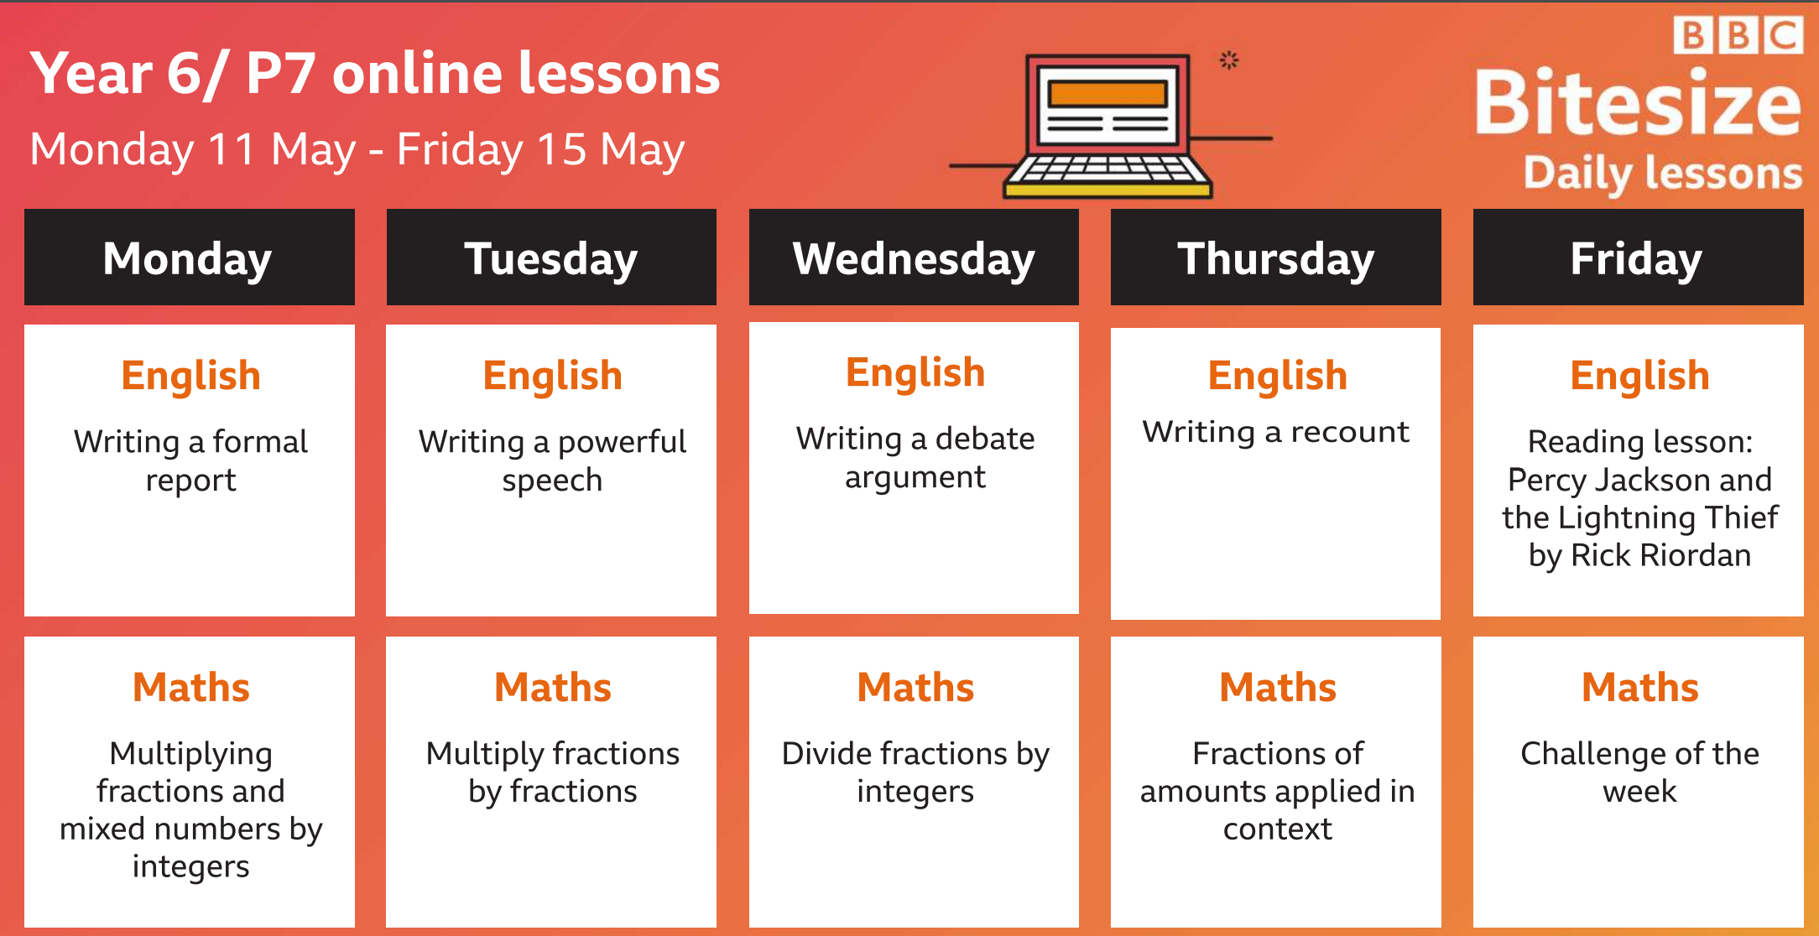
Science | LO: To understand different gestation periods  - Read through the Power point and the table of different gestation periods  - Complete the worksheet, ordering different gestation periods
Music | LO: To appreciate a range of music genres  Listen to the Davis Walliams podcast 5 – Ballet  Pay particular attention to the last piece of music- Prokofiev: Romeo and Juliet –  How does this make you feel?  https://www.classicfm.com/music-news/david-walliams-marvellous-musical-podcast/
PE | Complete a daily Joe Wicks workout  https://www.youtube.com/watch?v=lEWcBIvqjDk
French | Sign up to Duolingo.com, this is free of charge and challenges you to fun, daily activities.
History | Each week, Radio 4 will be releasing a 15 minute history lesson. You can listen live at 9:30 each Monday or catch up on BBC Sounds.  https://www.bbc.co.uk/programmes/m000hmmf/episodes/guide
Walk to school week | This week is ‘Walk to school week’ Each day take a walk with your family and try these activities.  Monday – Maths focus.  Over the course of the week log how far you have walked- this could be by counting your steps or use a tracking app on a smart phone to log you distance. Add up how far you have walked all week- measure this in km and convert to miles.  Tuesday Mental health focus Enjoy the mental and physical health benefits of walking Briskly walking, helps you feel fitter and happier. How does it make you feel? What do they notice on your walk? Who do they see as you walk through your community? What do you enjoy about it?  Wednesday: Geography focus  Use maps/ Google maps to plan a new walking route. Try and describe your journey using compass directions (there are lots of free Apps to download a compass onto a smart phone)  Thursday: History focus  During your walk, can you identify local landmarks? Can you spot architectural features such as date stones in houses?  Friday: Science focus  Walking is a great way to explore nature, during your walk why not start a small scrapbook to record information about plants and animal species? It could include photos, plant sprigs, sketches or tables to record plant growth throughout the week.

Please do not hesitate to contact us if you have any queries/questions about the content of this letter.

Yours sincerely,

Mrs Lilley

