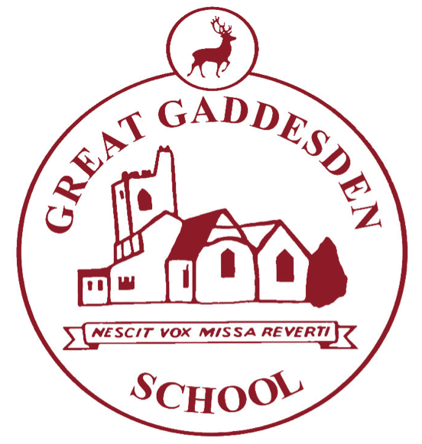
Homework at Great Gaddesden CofE School (VA)

Term: | Autumn 2 2018 | Year Group/s: | 5&6
At Great Gaddesden CofE School, we provide homework for three reasons:

- To reinforce learning that takes place in school.
- To give children further opportunities to develop their love of learning.
- To prepare children for the next stage in their learning, at secondary school, when the volume of homework significantly increases.

- Homework books should be handed in every Monday (unless specified otherwise) and will be returned on Wednesdays.
- Please write in your child’s reading record whenever you hear them read – this is true even if they are a free reader.
- Times tables test: A record of your child’s times-table achievements are completed in the back of their homework books.
- If homework is not completed, children will be expected to stay in, either at break or lunch-time, to complete it.
- When choosing a reading book, consider selecting from one of the following authors: Michael Morpurgo, Roald Dahl, Philip Pullman, Terry Pratchett, Anthony Horowitz, Alex Shearer, Caroline Lawrence, JK Rowling, Lauren Child, Lemony Snickett, CS Lewis, Laura Ingalls Wilder

Homework Set | Homework
Wednesday 7th November | Focus: History/English  WALT: write a cinquain poem  Task: This week we have been writing cinquain poems about the anniversary of WW1. Please take time to reflect on this event on Sunday. You need to create a cinquain poem about a subject of your choice. You may want to write about Remembrance Day or any other topic.  WILF:  Cinquain poems –  - Five lines  - 1st line has one noun  - 2nd line has two adjectives  - 3rd line has 3 ‘ing’ verbs  - 4th line describes the noun  - 5th line has one specific noun  Spelling: Please see your child’s Look, Cover, Write, Check sheet to see their spelling score for this week. Please ensure they spend time each day completing a column of this week’s spelling words. This is an opportunity to practice letter formation and handwriting as well as spelling.  My Maths: Our Maths topics this half-term include: Fractions, decimals, percentages, ratio and proportion, algebra, statistics and measurements. Please encourage your child to access these topics on My Maths.
Wednesday 14th November | Focus: Reading  WALT: Comprehend a text.  Task: You have been provided with a text. Read the text carefully and then answer the questions. You can refer to the text to help you answer the questions. For some questions you will need to provide evidence from the text, others will require your opinion.  Spelling: Please see your child’s Look, Cover, Write, Check sheet to see their spelling score for this week. Please ensure they spend time each day completing a column of this week’s spelling words. This is an opportunity to practice letter formation and handwriting as well as spelling.  My Maths: Our Maths topics this half-term include: Fractions, decimals, percentages, ratio and proportion, algebra, statistics and measurements. Please encourage your child to access these topics on My Maths.
Wednesday 21st November | Focus: Maths  WALT: Problem solving  Task:  Complete the puzzle scrolls sheet provided  Spelling: Please see your child’s Look, Cover, Write, Check sheet to see their spelling score for this week. Please ensure they spend time each day completing a column of this week’s spelling words. This is an opportunity to practice letter formation and handwriting as well as spelling.  My Maths: Our Maths topics this half-term include: Fractions, decimals, percentages, ratio and proportion, algebra, statistics and measurements. Please encourage your child to access these topics on My Maths.
Wednesday 28th November | Focus: RE  WALT: understand advent as a period of waiting  TASK: Research what an advent wreath symbolizes. You can present this as a drawing with labels or make your own 3d advent wreath!  Spelling: Please see your child’s Look, Cover, Write, Check sheet to see their spelling score for this week. Please ensure they spend time each day completing a column of this week’s spelling words. This is an opportunity to practice letter formation and handwriting as well as spelling.  My Maths: Our Maths topics this half-term include: Fractions, decimals, percentages, ratio and proportion, algebra, statistics and measurements. Please encourage your child to access these topics on My Maths.
Wednesday 5th December | Focus: Science  WALT: research colour blindness and understand how it affects people  In Science we have been learning how light enables us to see and how we can see different colours. Research colour blindness – what is it? How does it affect people? See if you can find and take a colour blindness test. You may want to present your findings as an information leaflet or booklet which will teach people about colour blindness, a fact file with bullet points or a personal account of what you have found out about colour blindness, including your results from the test and what you thought about it.  Spelling: Please see your child’s Look, Cover, Write, Check sheet to see their spelling score for this week. Please ensure they spend time each day completing a column of this week’s spelling words. This is an opportunity to practice letter formation and handwriting as well as spelling.  My Maths: Our Maths topics this half-term include: Fractions, decimals, percentages, ratio and proportion, algebra, statistics and measurements. Please encourage your child to access these topics on My Maths.
Wednesday 12th December | Focus: History  WALT:  Task:  My Maths: Our Maths topics this half-term include: Fractions, decimals, percentages, ratio and proportion, algebra, statistics and measurements. Please encourage your child to access these topics on My Maths.
Wednesday 14th December | Focus: R.E  WALT: Research Christmas around the world.  Task: Below you have a range of Christmas facts. Your task is to find out which customs belong to which country.  *December 26th is called Boxing Day and was traditionally a day to give presents to the poor.  *Tropical flowers are used as Christmas decorations.  *The three Kings arrive on the night of January 5th to give presents to children. Most towns have a carnival style parade through the streets.  *On January 6th a special almond cake with a toy crown inside is eaten.  *Wooden decorations and candles are put in windows of homes.  *Due to the population of Christians being so low, Christmas is only celebrated in the big cities where Christmas trees are put up.  *Fir trees grow here and they always send the biggest and most beautiful fir tree to Boston in the USA.  The countries you will need to research are:  China, Great Britain, France, Germany, Spain, Costa Rica, Canada  Spelling: Please see your child’s Look, Cover, Write, Check sheet to see their spelling score for this week. Please ensure they spend time each day completing a column of this week’s spelling words. This is an opportunity to practice letter formation and handwriting as well as spelling.  My Maths: Our Maths topics this half-term include: Fractions, decimals, percentages, ratio and proportion, algebra, statistics and measurements. Please encourage your child to access these topics on My Maths.

