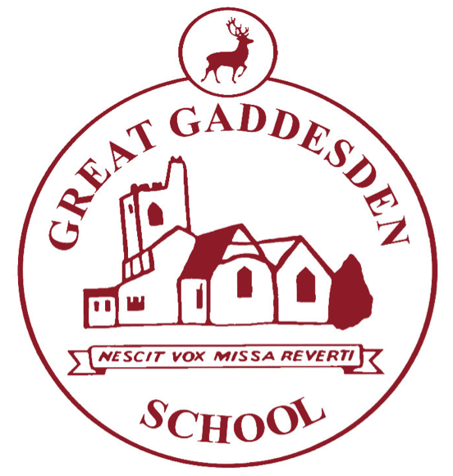
Homework at Great Gaddesden CofE School (VA)

Term: | Autumn 1, 2019 | Year Group/s: | 5&6
At Great Gaddesden CofE School, we provide homework for three reasons:

- To reinforce learning that takes place in school.
- To give children further opportunities to develop their love of learning.
- To prepare children for the next stage in their learning, at secondary school, when the volume of homework significantly increases.

- Homework books should be handed in every Monday (unless specified otherwise) and will be returned on Wednesdays.
- Please write in your child’s reading record whenever you hear them read – this is true even if they are a free reader.
- Times tables test: A record of your child’s times-table achievements are completed in the back of their homework books.
- If homework is not completed, children will be expected to stay in, either at break or lunch-time, to complete it.
- When choosing a reading book, consider selecting from one of the following authors: Michael Morpurgo, Roald Dahl, Philip Pullman, Terry Pratchett, Anthony Horowitz, Alex Shearer, Caroline Lawrence, JK Rowling, Lauren Child, Lemony Snickett, CS Lewis, Laura Ingalls Wilder

Homework Set | Homework
Wednesday 11th September | Focus: History DL  LO: Research the life of an important historical figure  Task: Research the life of either Neville Chamberlain or Adolph Hitler. You may present the information as a biography, leaflet or an A4 poster.  WILF:  - Date and learning objective  - Very neat presentation  - Photographs/ illustrations  - A timeline of their life  - Clear and coherent sentences in your own words. Please do not copy and paste from the internet.  Additional Task: Please cover your homework book in wrapping paper to ensure that it looks neat and is protected for the year ahead.  My Maths: Our Maths topics this half-term include: Number and place value, the four operations (addition, subtraction, multiplication and division) Geometry of Shapes and Position and direction. Please encourage your child to access these topics on My Maths.
Wednesday 18th September | Focus: English grammar DL  LO: improve understanding of English grammar  Task: Complete the work sheet provided.  WILF:  - Date and learning objective  - Very neat presentation  - Sheet neatly stuck in books  Spelling: Please see your child’s Look, Cover, Write, Check book to see their spelling score for this week. Please ensure they spend time each day completing a column of this week’s spelling words. This is an opportunity to practice letter formation and handwriting as well as spelling.  My Maths: Our Maths topics this half-term include: Number and place value, the four operations (addition, subtraction, multiplication and division) Geometry of Shapes and Position and direction. Please encourage your child to access these topics on My Maths.
Wednesday 25th September | Focus: Maths DL  LO: Understand place value  Task: Complete the Target maths sheet.  WILF:  - Date and learning objective  - Questions copied and completed neatly into homework books  Spelling: Please see your child’s Look, Cover, Write, Check book to see their spelling score for this week. Please ensure they spend time each day completing a column of this week’s spelling words. This is an opportunity to practice letter formation and handwriting as well as spelling.  My Maths: Our Maths topics this half-term include: Number and place value, the four operations (addition, subtraction, multiplication and division) Geometry of Shapes and Position and direction. Please encourage your child to access these topics on My Maths.
Wednesday 2nd October | Focus: RE  LO: Consider the ultimate questions.  Task: Choose three ultimate questions from the list provided. Discuss these questions with a member of your family and write a paragraph suggesting what the answer to these questions might be. Remember there are no right or wrong answers.  WILF:  - Date and learning objective  - Very neat presentation.  - Writing in complete sentences  - A paragraph for each question. Three in total  Spelling: Please see your child’s Look, Cover, Write, Check book to see their spelling score for this week. Please ensure they spend time each day completing a column of this week’s spelling words. This is an opportunity to practice letter formation and handwriting as well as spelling.  My Maths: Our Maths topics this half-term include: Number and place value, the four operations (addition, subtraction, multiplication and division) Geometry of Shapes and Position and direction. Please encourage your child to access these topics on My Maths.
Wednesday 9th  October | Focus: Science CJ  LO: To classify items by their properties.  Task: Select 20 different items in your house, these can be a pen, a pencil, tin foil, a table, a sofa, a window, a pair of curtains, etc. Write down your 20 items, you could take a picture of them to include too. Decide how you are going to sort the different items by taking into consideration the properties they have – hard, soft, flexible, waterproof, transparent, opaque, etc.  You may wish to classify your items in a Venn Diagram, Carroll Diagram, a list, etc.  When you have grouped your items, you will need to write a short paragraph about each category explaining why you chose to categorise them in this way.  There is no right or wrong way to complete this task, but you must include your reasoning in writing.  Spelling: Please see your child’s Look, Cover, Write, Check book to see their spelling score for this week. Please ensure they spend time each day completing a column of this week’s spelling words. This is an opportunity to practice letter formation and handwriting as well as spelling.  My Maths: Our Maths topics this half-term include: Number and place value, the four operations (addition, subtraction, multiplication and division) Geometry of Shapes and Position and direction. Please encourage your child to access these topics on My Maths.
Wednesday 16th  October | Focus: Art DL  LO: Research different home front images  Task: Collect a range of images of Britain’s home front. These will be used in class to create a collage  Spelling: Please see your child’s Look, Cover, Write, Check book to see their spelling score for this week. Please ensure they spend time each day completing a column of this week’s spelling words. This is an opportunity to practice letter formation and handwriting as well as spelling.  My Maths: Our Maths topics this half-term include: Number and place value, the four operations (addition, subtraction, multiplication and division) Geometry of Shapes and Position and direction. Please encourage your child to access these topics on My Maths.
Wednesday 23rd October | Focus: Maths DL  LO: Understand multiplication  Task: Complete the Target maths sheet.  WILF:  - Date and learning objective  - Questions copied and completed neatly into homework books  Spelling: Please see your child’s Look, Cover, Write, Check book to see their spelling score for this week. Please ensure they spend time each day completing a column of this week’s spelling words. This is an opportunity to practice letter formation and handwriting as well as spelling.  My Maths: Our Maths topics this half-term include: Number and place value, the four operations (addition, subtraction, multiplication and division) Geometry of Shapes and Position and direction. Please encourage your child to access these topics on My Maths.

