Great Gaddesden C of E

(Voluntary Aided) Primary School

Telephone 01442 255734 Headteacher: Mrs. S Wickens

Great Gaddesden

Email admin@greatgaddesden.herts.sch.uk Hemel Hempstead

Herts

Website www.greatgaddesden.herts.sch.uk HP1 3BT

Friday 7th September 2018

Dear Parents/Carers,

This letter outlines the curriculum for Years 3 and 4 for the Autumn Term. We are keen to share with you what we are learning in school in order for you to support your child/ren at home.

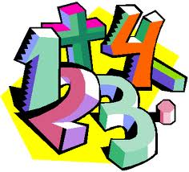
In Maths this term we will be studying the following units: Number and Place Value, Addition and Subtraction, Multiplication and Division, Fractions, Statistic, Measurement, Geometry: Properties of Shape, Geometry: Position and Direction as well as developing our mental maths skills and our problem-solving skills. In addition we will be focusing upon the rapid recall of multiplication facts and the corresponding division fact.

In English this term we will be studying the following units: instructional writing, performance poetry and descriptive writing based around the text Stig of the Dump. During the second half of the Autumn Term we will be writing recounts and explanation texts.

In R.E. this half-term we will be studying the lives of key religious leaders including Jesus and Mohammed. After half-term, we shall be learning about ways of describing God and the meaning behind Christmas.
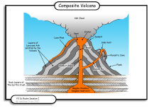
In our Science lessons, our topic is ‘Rocks and Soils’ we will be developing our scientific vocabulary and skills by researching different rocks and where they are used. We will investigate how rocks are different and record and classify their usage through observations and fair testing. After half-term, we will be studying sound and how it is made and changed.

Our Computing lessons will start by looking at E-Safety and then move on to focus on ‘Coding’. We will learn what coding is, as well as how to come up with algorithms (a set of instructions) to ensure we use technology to help us. After half term we will use Garage Band to edit and compose music tracks.

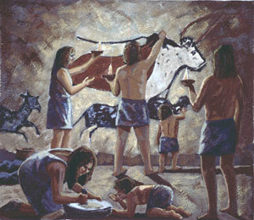
In History this term our topic is the ‘Stone Age’. We will be learning about how prehistoric man lived and hunted to survive. The children will be encouraged to use their enquiry skills to explore the settlement of Skara Brae as well as Stonehenge.

In Art this term we will be developing our drawing skills. We will be learning about different printing methods and the life and work of Andy Warhol. We will be working towards creating a piece of work inspired by Warhol.

In Music this term, children will be learning how to play the recorder. These lessons will be delivered by the Hertfordshire Wider Opportunities Music Scheme.

During our P.E. and Games lessons we will be learning the skills needed for playing football and hockey. We will also be creating our own dance and gymnastics routines.

In PSHE this term, the children will be introduced to ‘Mindfulness’ and how this can help them with their learning and concentration.

Finally, homework will be set on a Wednesday ready to be handed back into school on Monday. Homework will consist of one written piece of homework linking to work children have done in class, and a spelling list to practise over the week as well as a My Maths focus. If you have any questions or concerns about your child’s homework please feel free to leave a comment in their homework book or come and see us. We really appreciate your input and support.

We will be hosting a meeting for parents of Year 3 & 4 children on Tuesday 18th September at 3:00pm to discuss the year ahead as well as share any questions/queries you may have. Please come into the classroom via the playground.

As always, please do not hesitate to contact us if you have any questions or queries regarding the content of this letter.

Yours sincerely,

Mrs Jessop and Mrs Lilley

