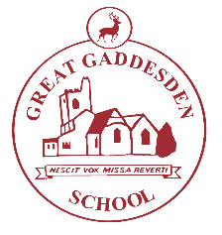
Great Gaddesden C of E

(Voluntary Aided) Primary School

Telephone 01442 255734 Headteacher Mrs S. Wickens

Great Gaddesden

Email head@greatgaddesden.herts.sch.uk Hemel Hempstead

admin@greatgaddesden.herts.sch.uk Herts

Website www.greatgaddesden.herts.sch.uk HP1 3BT

September 2019

Dear Parents/Carers,

This letter outlines the curriculum for Years 3 and 4 for the Autumn Term. We are keen to share with you what we are learning in school in order for you to support your child/ren at home.

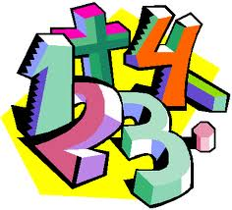
In Maths this term we will be studying the following units: Number and Place Value, Addition and Subtraction, Multiplication and Division, Fractions, Statistic, Measurement, Geometry: Properties of Shape, Geometry: Position and Direction as well as developing our mental maths skills and our problem-solving skills.

In addition we will be focusing upon the rapid recall of multiplication facts and the corresponding division fact.

In English this term we will be studying the following units: Recounts, Poetry and Stories about Roman life, Non chronological Reports and Myths and Legends.

In R.E. this half-term, our topic is ‘Belonging: Hinduism Teaching about God’. During this unit of work, we shall learn about what Hindus teach their children about God. After half-term, we shall be learning about how Advent and Christmas are celebrated around the world.

In our Science lessons, our topic is ‘Forces and magnets’ where the children will learn that forces are pushes and pulls which can make things move, stop or change shape. We will also be setting up and conducting comparative fair tests, then learning to record measurements taken and discuss the results.

Our ICT lessons will be focused on designing and creating a comic strip using a storyboard creator. After half term we will meteorologists learning about the weather and presenting the weather.

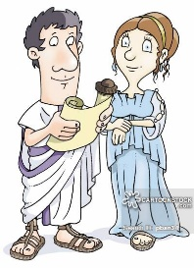In History this term our topic is the Romans. We will be learning about how they lived, worshipped and fought. We are planning to have a Roman day later on in the term!

In Art this term we will be developing our drawing skills. We will be learning about perspective and looking at the work of Vermeer in particular. After half term the children will have opportunity to create a mosaic, linking in with their topic on the Romans.

In Music this term, the topics we will be learning about are: Animal magic, exploring descriptive sounds through animal songs. In the second half term we will be learning rhythmic patterns through well-known children’s songs.

During our P.E. and Games lessons we will be learning the skills needed for playing football and tag rugby. We will also be learning about dance and gymnastics.

In PSHE this term, our units are entitled ‘Strengths and Challenges,’ and ‘Identity, society and equality.’

As always, please do not hesitate to contact us if you have any questions or queries regarding the content of this letter.

Yours sincerely,

Mrs Todiresei

