Great Gaddesden C of E

(Voluntary Aided) Primary School

Telephone 01442 255734 Headteacher: Mrs S Wickens

Great Gaddesden C of E School,

Hemel Hempstead

Herts

HP1 3BT

Email admin@greatgaddesden.herts.sch.uk

Website www.greatgaddesden.herts.sch.uk
Spring 1, 2018

Dear Parents/Carers,

This letter outlines the curriculum for Years 3 and 4 for the Spring Term. We are keen to share with you what we are learning in school in order for you to support your child/ren at home.

In Maths this term we will be studying the following units: Number and Place Value, Addition and Subtraction, Multiplication and Division, Fractions, Statistic, Measurement, Geometry: Properties of Shape, Geometry: Position and Direction as well as developing our mental maths skills and our problem-solving skills.

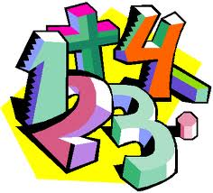

In addition we will be focusing upon the rapid recall of multiplication facts and the corresponding division fact.

In English this term we will be studying the following units: Explanation texts, Instructions and Poetry. We will also be paying particular attention to the rules of English grammar including the rules of speech, sentence types and the use of conjunctions.

Our learning in RE is around belonging and Sikhism. We will study what it means to belong to an organisation thinking about what we might experience as well as how this might make us feel. Later in the term we will research and understand the 5K’s which are important to Sikhs as well as the importance of food in the religion.

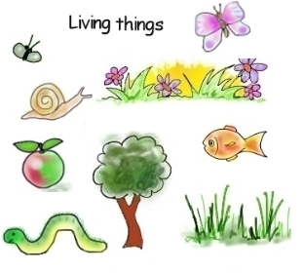
In our Science lessons we will be studying living things. We will learn that living things can be grouped in a variety of ways, explore and use classification keys to help group, identify and name a variety of living things in their local and wider environment and recognise that environments can change and that this can sometimes pose dangers to living things.

Computing – In the first half term we will be using software to create surveys in our unit called ‘We are opinion pollsters’. Once the children have chosen a topic to survey they will gather the results and discuss the outcomes. After half term we will be learning how to create a database discovering at how this used to be done as well as how computing has changed this process.

In Geography this term the children will be studying volcanoes. There will also be a focus upon Italy and its physical and human geography.

Art – Using several APP’s the children will learning how we can take a photograph and manipulate this to change and enhance the image.

During our DT lessons the children will be designing and making healthy smoothies.

In Music this term, children will be learning how to play the ukele. These lessons will be delivered by Miss Vineyard from the Hertfordshire Wider Opportunities Music Scheme.
.
During our P.E. and Games lessons we will be learning the skills needed for playing hockey and during gymnastics we will be looking at creating symmetrical and asymmetrical shapes. Furthermore, as part of our continuing investment in P.E, the children will also be participating in BMX lessons.

During PSHE we will discuss the relationships we have, and how we can fall in and out with friends. In particular, how we can look for clues in how people might respond to things so that know how they might feel.

Finally, homework will be set on a Wednesday ready to be handed back into school on Monday. Homework will consist of one written piece of homework linking to work children have done in class, a times table and spelling list to practise over the week as well as a grammar focus for their reading and a Mymaths task. If you have any questions or concerns about your child’s homework please feel free to leave a comment in their homework book or come and see us. We really appreciate your input and support.

As always, please do not hesitate to contact us if you have any questions or queries regarding the content of this letter.

Yours sincerely,

Mrs Jessop and Mrs Lilley

