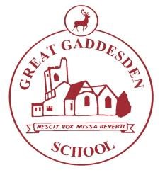
Great Gaddesden Cof E (VA) Primary School
Headteacher: Mrs S.M.Wickens

Great Gaddesden C of E Primary School
Church Meadow
Great Gaddesden
Herts
HP1 3BT

Email: admin@greatgaddesden.herts.sch.uk
Website: www.greatgaddesden.herts.sch.uk
Tel: 01442 255734

Dear Parents,

We have provided a pack of learning activities for children to complete at home due to school closure. Each day may we suggest that you complete one maths task, one reading task and one writing task. We also feel it would be beneficial for the children to spend some time outside each day, if appropriate, the National Trust website has lots of creative activities children may want to take part in.

Maths
- Continue using ‘Rockstars’ for learning times tables.
- A pack of times tables games and activities.
- A maths activity booklet covering a range of areas.

Reading
- Continue regular reading using your school reading book or ‘Reading for Pleasure’ book.
- Comprehension activities.
Writing
- A range of activities based on a text called The Wyrmstooth Crown.
- Writing a topic report about ‘Mighty Mountains and Violent Volcanoes.’

R.E.
- Research the story of ‘Moses and the Red Sea.’
- Re-write the story in your own words.

Suggested Websites
Rockstars
The National Trust
primaryhomeworkhelp.co.uk

Please continue to stay safe and healthy.

Yours Sincerely,

Mrs E. De Rouffignac.

