Great Gaddesden C of E (VA) Primary School
Headteacher: Mrs S.M.Wickens

Great Gaddesden C of E Primary School
Church Meadow,
Great Gaddesden.
Herts.
Email: admin@greatgaddesden.herts.sch.uk
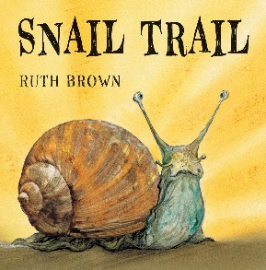
Website: www.greatgaddesden.herts.sch.uk
Tel: 01442 255734

Nursery Home Learning wb 29th June

The Snail Trail

Please find below a week of learning challenges based on the story The Snail Trail by Ruth Brown.

There is no expectation to complete all of the activities. Please complete as many as you like. Have fun!

Book:
This week, we would like you to listen to the story ‘The Snail Trail. If you do not have the story at home, there is a YouTube video link below.
Book link: https://www.youtube.com/watch?v=XsCgl6DobN4

Activities:
- Create your own snail using playdough as its body…what could you use as a shell? Be as imaginative as possible! Eg. Cotton reel, pine cone, part of a toilet roll tube.

- In the story the snail goes on an adventure. Can you take your snail on an adventure using your imagination using positional language – under, over, on top etc.

- Draw some pictures about where your snail went on it’s adventure.

- Watch this video about snails. https://www.youtube.com/watch?v=ki97nLa2rjk. Can you tell a grown up any facts you remember about snails.

- Get a grown up to draw a large snail with a shell, using loose parts eg. Stones, leaves, pom poms, beads etc can you fill in the snail’s shell.

- https://www.twinkl.co.uk/resource/roi-sc-49-making-a-snailery-instructions-activity
Create a snailery and watch the snails! You could take some photos.

