Week Beginning 14th September
Practice your spellings every day. Below are some ideas on how to practice spellings:
- Complete a Look, Cover, Write, Check sheet
- Rainbow writing (write the word several times in different coloured pens or pencils
- Find the words in a dictionary
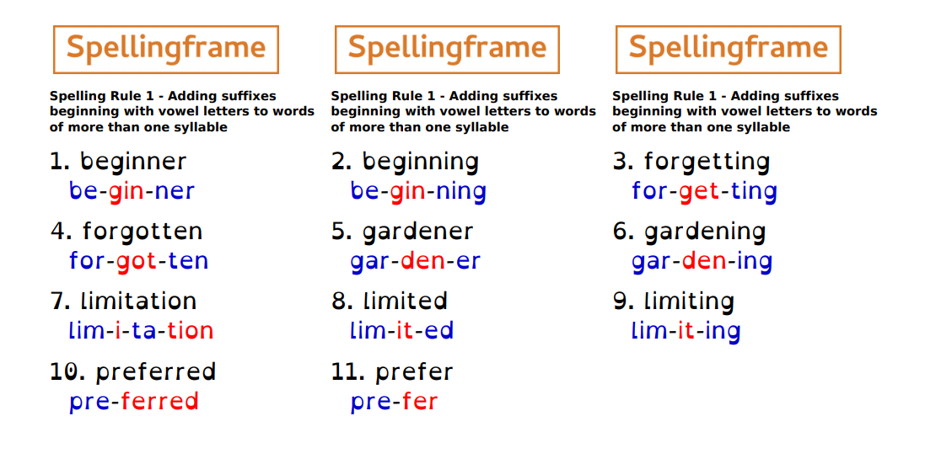
Spelling Rule 1

Maths Home Learning
Please complete the Oak Academy lesson. Watch the video and work through any questions.
Yr 3 Reading and writing 3 digit numbers https://classroom.thenational.academy/lessons/reading-and-writing-3-digit-numbers-ccrk4r
Yr 4: Recognising place value https://classroom.thenational.academy/lessons/recognising-the-place-value-of-each-digit-in-a-4-digit-number-cgup6r

Topic Home Learning
Select four of the tasks that you wish to focus on. You may present your work in a variety of ways including; a Power Point presentation, a poster or leaflet, a video- just use your imagination!
This project work will be due the week beginning October 12th. During the following week, you will be able to showcase your work with the class. This will support your presentation, speaking and listening skills.
