Great Gaddesden C of E (VA) Primary School
Headteacher: Mrs S.M.Wickens

Great Gaddesden C of E Primary School
Church Meadow,
Great Gaddesden.
Herts.
Email: admin@greatgaddesden.herts.sch.uk
Website: www.greatgaddesden.herts.sch.uk
Tel: 01442 255734

EYFS Home Learning week beginning 18th May 2020 Superworm
This week it would usually be ‘Walk to School Week’. We have set you a challenge to find different things each day on your walk.
- Monday- a stick that looks like a wiggly worm
- Tuesday- 3 blue cars, 4 red cars and one yellow car
- Wednesday- 5 things that begin with ‘w’
- Thursday- count how many cats, dogs or squirrels you see
- Friday- something of every colour of the rainbow (and it can’t be a picture of a rainbow!)
This week we would like you to read (if you have a copy) or watch the story ‘Superworm’ and complete the learning tasks. The link for the story is below. (Please ensure if your child is watching the story on YouTube that an adult is nearby to supervise).
- Superworm on YouTube https://www.youtube.com/watch?v=7Jnk3XApKBg

Monday | 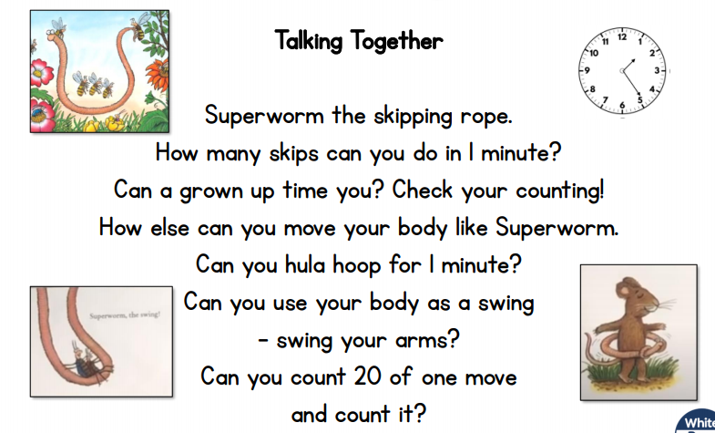  Using the Nature Walk Scavenger Hunt sheet below, see how many items you can find when you next go for a walk. Talk about where you found them. Why are they there? Will we see them all year round? What might change throughout the year?
Tuesday | Go on a sound hunt around your house/garden. How many things can you find that begin with w?  Chocolate Art Challenge-Jackson Pollock  *Watch video https://www.tate.org.uk/kids/make/paint-draw/make-chocolate-painting and have a go at creating your own chocolate art (it can be easily done using clingfilm on a baking tray or chopping board) and enjoy!
Wednesday | 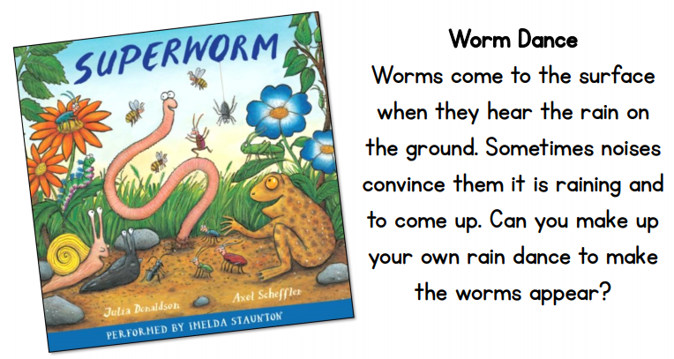  Here is an example. Can you make up your own?  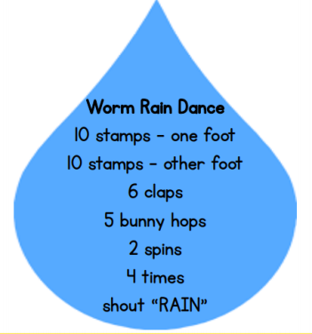  Practical prayer at home (see below)
Thursday | Think about the time that you have had at home. What have been your favourite things to do? It might be playing in the garden, or going for walks? It might be reading stories with your family or playing with your toys.  Draw some pictures of you doing those things so you can share with your friends when we go back to school.
Friday | 